Mobile Carrier Networks

📶 What Are Mobile Carrier Networks?
# Source: Chatgpt (GPT-5-Mini) at [1/23/2026]
A Mobile Carrier Network (also called Mobile Network Operator, MNO, or cellular network) is a telecommunications company that provides wireless communication services to mobile phone users.
In simple terms:
🔌 It’s the infrastructure that allows phones to make calls, send texts (SMS), and access mobile internet.

📡 Key Components of a Mobile Carrier Network
# Source: Chatgpt (GPT-5-Mini) at [1/23/2026]
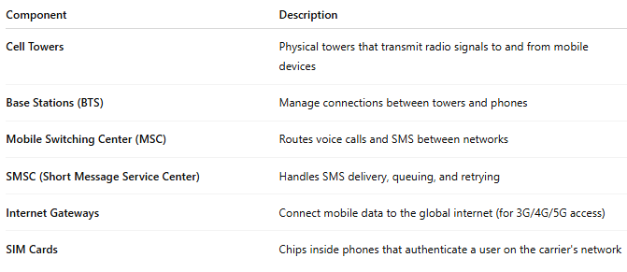

Component | Description
Cell Towers | Physical towers that transmit radio signals to and from mobile devices
Base Stations (BTS) | Manage connections between towers and phones
Mobile Switching Center (MSC) | Routes voice calls and SMS between networks
SMSC (Short Message Service Center) | Handles SMS delivery, queuing, and retrying
Internet Gateways | Connect mobile data to the global internet (for 3G/4G/5G access)
SIM Cards | Chips inside phones that authenticate a user on the carrier's network

📱 What Services Do They Provide?
# Source: Chatgpt (GPT-5-Mini) at [1/23/2026]
- Voice calling 📞
- SMS (text messaging) 💬
- Mobile data (3G, 4G, 5G) 🌐
- Roaming (connect to other carriers while abroad) ✈️
- Value-added services (voicemail, caller tune, etc.) 🎵

🏢 Examples of Mobile Carrier Networks
# Source: Chatgpt (GPT-5-Mini) at [1/23/2026]
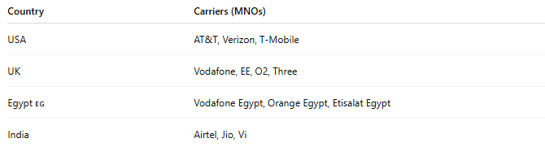
Country | Carriers (MNOs)
USA | AT&T, Verizon, T-Mobile
UK | Vodafone, EE, O2, Three
Egypt 🇪🇬 | Vodafone Egypt, Orange Egypt, Etisalat Egypt
India | Airtel, Jio, Vi

🔁 Connection with SMS System
# Source: Chatgpt (GPT-5-Mini) at [1/23/2026]
When your app sends an SMS via an SMS Gateway, that gateway connects to the mobile carrier network, which then delivers the SMS to the recipient’s phone.

📱 Mobile Carrier Network vs Mobile Network Operator (MNO)
# Source: Chatgpt (GPT-5-Mini) at [1/23/2026]
Great question! ✅ They’re related — but not exactly the same.

📱 Mobile Carrier Network vs Mobile Network Operator (MNO)
# Source: Chatgpt (GPT-5-Mini) at [1/23/2026]
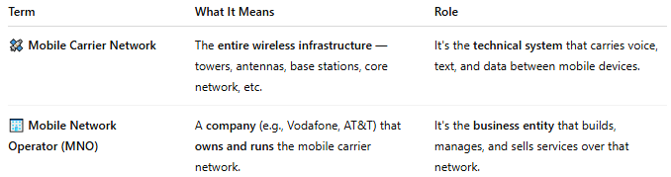

Term | What It Means | Role
🛰️ Mobile Carrier Network | The entire wireless infrastructure — towers, antennas, base stations, core network, etc. | It's the technical system that carries voice, text, and data between mobile devices.
🏢 Mobile Network Operator (MNO) | A company (e.g., Vodafone, AT&T) that owns and runs the mobile carrier network. | It's the business entity that builds, manages, and sells services over that network.

📌 In Short:
# Source: Chatgpt (GPT-5-Mini) at [1/23/2026]
- ✅ The Mobile Carrier Network is the system.
- ✅ The MNO is the company that runs that system.

🧠 Example:
# Source: Chatgpt (GPT-5-Mini) at [1/23/2026]
Vodafone (MNO) owns and operates the Vodafone mobile network (carrier network), which includes:
- Cell towers
- Base stations
- Core systems
- Licensed spectrum
- Roaming infrastructure
So when you connect to "Vodafone" on your phone, you're accessing their mobile carrier network, operated by the MNO (Vodafone).

